NAME : **FAIZAH ALI**

USN : **1NT18IS057**

**BIG DATA LAB LA2**

Hadoop Map-reduce Programming :

Hadoop MapReduce is a software framework for easily writing applications which process vast amounts of data (multi-terabyte data-sets) in-parallel on large clusters (thousands of nodes) of commodity hardware in a reliable, fault-tolerant manner.

A MapReduce *job* usually splits the input data-set into independent chunks which are processed by the *map tasks* in a completely parallel manner. The framework sorts the outputs of the maps, which are then input to the *reduce tasks*. Typically both the input and the output of the job are stored in a file-system. The framework takes care of scheduling tasks, monitoring them and re-executes the failed tasks.

Typically the compute nodes and the storage nodes are the same, that is, the MapReduce framework and the Hadoop Distributed File System are running on the same set of nodes. This configuration allows the framework to effectively schedule tasks on the nodes where data is already present, resulting in very high aggregate bandwidth across the cluster.

The MapReduce framework consists of a single master JobTracker and one slave TaskTracker per cluster-node. The master is responsible for scheduling the jobs' component tasks on the slaves, monitoring them and re-executing the failed tasks. The slaves execute the tasks as directed by the master.

Minimally, applications specify the input/output locations and supply *map* and *reduce* functions via implementations of appropriate interfaces and/or abstract-classes. These, and other job parameters, comprise the *job configuration*. The Hadoop *job client* then submits the job (jar/executable etc.) and configuration to the JobTracker which then assumes the responsibility of distributing the software/configuration to the slaves, scheduling tasks and monitoring them, providing status and diagnostic information to the job-client.

**Exercise-I**

Create a dataset in excel as .csv file and it should contain the following fields with at least 20 sample datasets in it.

Use the Hadoop MapReduce programming framework to come up with a Program which will take the data from this .csv file and computes the following.

1. Total number of employees who work in ISE department

2. Total number of employees with experience=5 years

3. Count the number of employees who lives in Bangalore

Dataset Snapshot :-

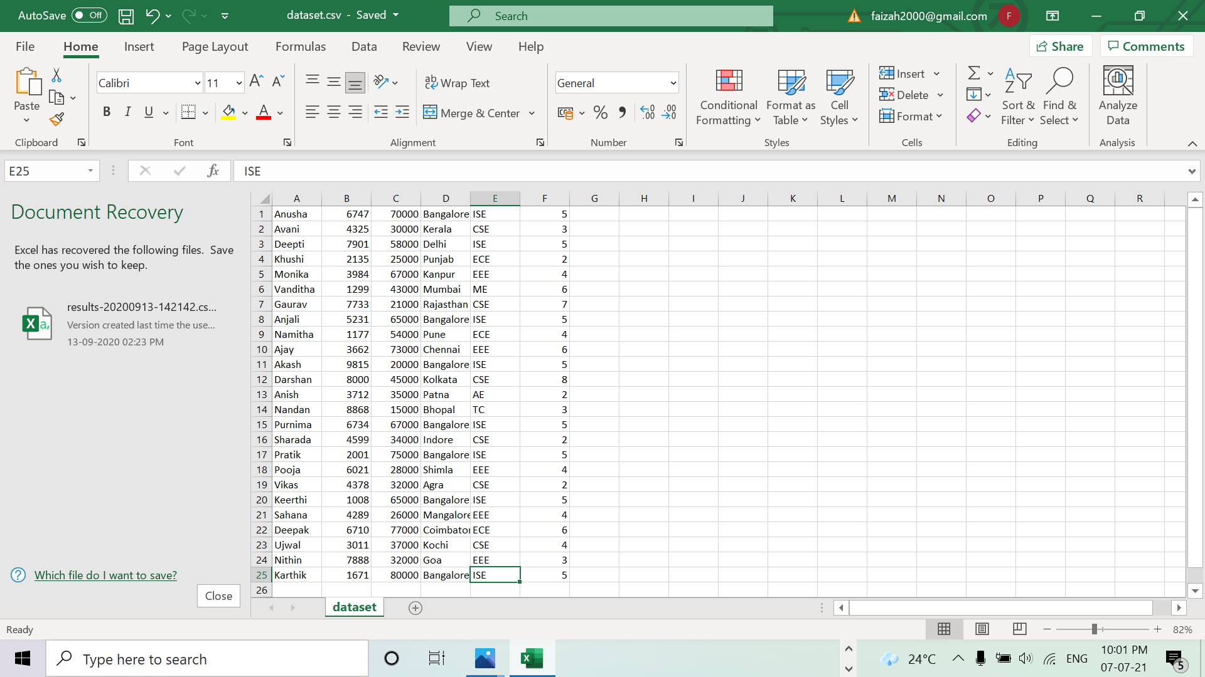

JAVA program screenshots :-

1. Employee Project -> EmpISE class

import java.io.IOException;

import java.util.*;

import org.apache.hadoop.fs.Path;

import org.apache.hadoop.io.*;

import org.apache.hadoop.mapred.*;

public class EmpISE {

//MAPPER CODE

public static class Map extends MapReduceBase implements Mapper<LongWritable, Text, Text, IntWritable> {

private final static IntWritable one = new IntWritable(1);

private Text word = new Text();

public void map(LongWritable key, Text value, OutputCollector<Text, IntWritable> output, Reporter reporter) throws IOException {

String data = value.toString();

String[] Ecount= data.split(",");

if (Ecount[4].equals("ISE")) {

output.collect(new Text("Total no.of employees working in ISE Department : "), one);

}

}

}

//REDUCER CODE

public static class Reduce extends MapReduceBase implements Reducer<Text, IntWritable, Text, IntWritable> {

public void reduce(Text key, Iterator<IntWritable> values, OutputCollector<Text, IntWritable> output, Reporter reporter) throws IOException { //{little: {1,1}}

int val = 0 ;

while(values.hasNext()) {

val += values.next().get();

}

output.collect(key, new IntWritable(val));

}

}

//DRIVER CODE

public static void main(String[] args) throws Exception {

JobConf conf = new JobConf(EmpISE.class);

conf.setJobName("Total no.of employees working in ISE Department");

conf.setOutputKeyClass(Text.class);

conf.setOutputValueClass(IntWritable.class);

conf.setMapperClass(Map.class);

conf.setCombinerClass(Reduce.class);

conf.setReducerClass(Reduce.class);

conf.setInputFormat(TextInputFormat.class);

conf.setOutputFormat(TextOutputFormat.class);

FileInputFormat.setInputPaths(conf, new Path(args[0]));

FileOutputFormat.setOutputPath(conf, new Path(args[1]));

JobClient.runJob(conf);

}

}

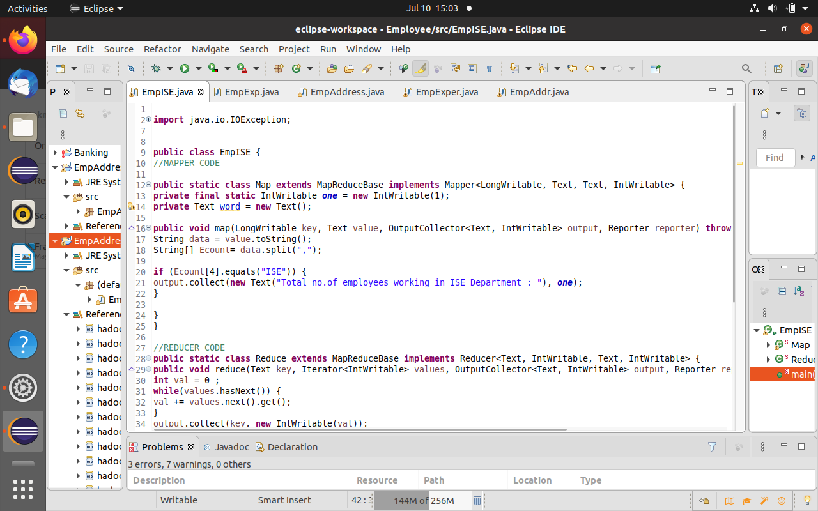

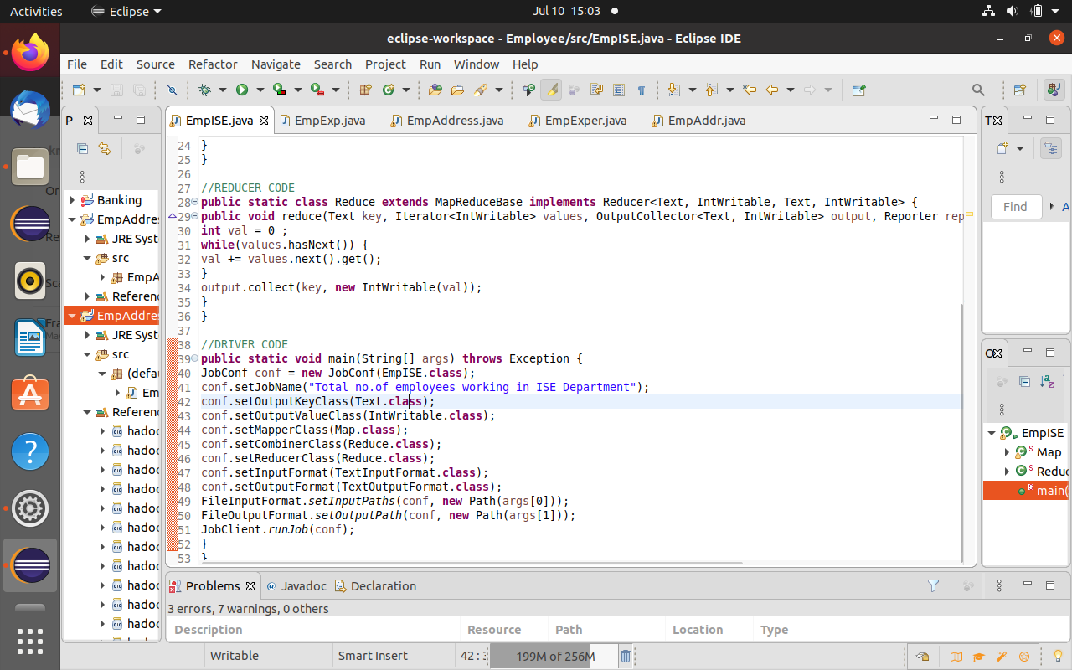

2.EmpExperience Project ->EmpExper class

import java.io.IOException;

import java.util.*;

import org.apache.hadoop.fs.Path;

import org.apache.hadoop.io.*;

import org.apache.hadoop.mapred.*;

public class EmpExper {

//Mapper Code

public static class Map extends MapReduceBase implements Mapper<LongWritable, Text, Text, IntWritable> {

private final static IntWritable one = new IntWritable(1);

private Text word = new Text();

public void map(LongWritable key, Text value, OutputCollector<Text, IntWritable> output, Reporter reporter) throws IOException {

String data = value.toString();

String[] Ecount= data.split(",");

if (Ecount[5].equals("5")) {

output.collect(new Text("Total no.of employees having 5 years of experience : "), one);

}

}

}

//REDUCER CODE

public static class Reduce extends MapReduceBase implements Reducer<Text, IntWritable, Text, IntWritable> {

public void reduce(Text key, Iterator<IntWritable> values, OutputCollector<Text, IntWritable> output, Reporter reporter) throws IOException { //{little: {1,1}}

int val = 0 ;

while(values.hasNext()) {

val += values.next().get();

}

output.collect(key, new IntWritable(val));

}

}

//DRIVER CODE

public static void main(String[] args) throws Exception {

JobConf conf = new JobConf(EmpExper.class);

conf.setJobName("Total no.of employees having 5 years of experience");

conf.setOutputKeyClass(Text.class);

conf.setOutputValueClass(IntWritable.class);

conf.setMapperClass(Map.class);

conf.setCombinerClass(Reduce.class);

conf.setReducerClass(Reduce.class);

conf.setInputFormat(TextInputFormat.class);

conf.setOutputFormat(TextOutputFormat.class);

FileInputFormat.setInputPaths(conf, new Path(args[0]));

FileOutputFormat.setOutputPath(conf, new Path(args[1]));

JobClient.runJob(conf);

}

}

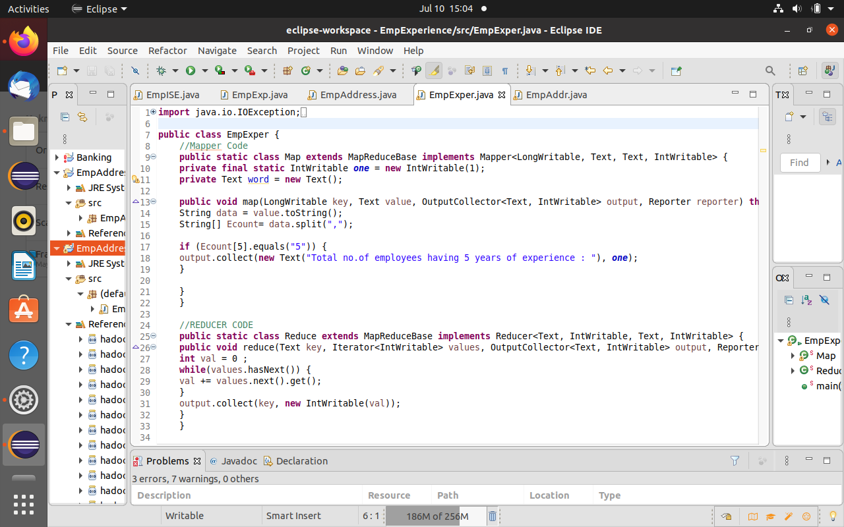

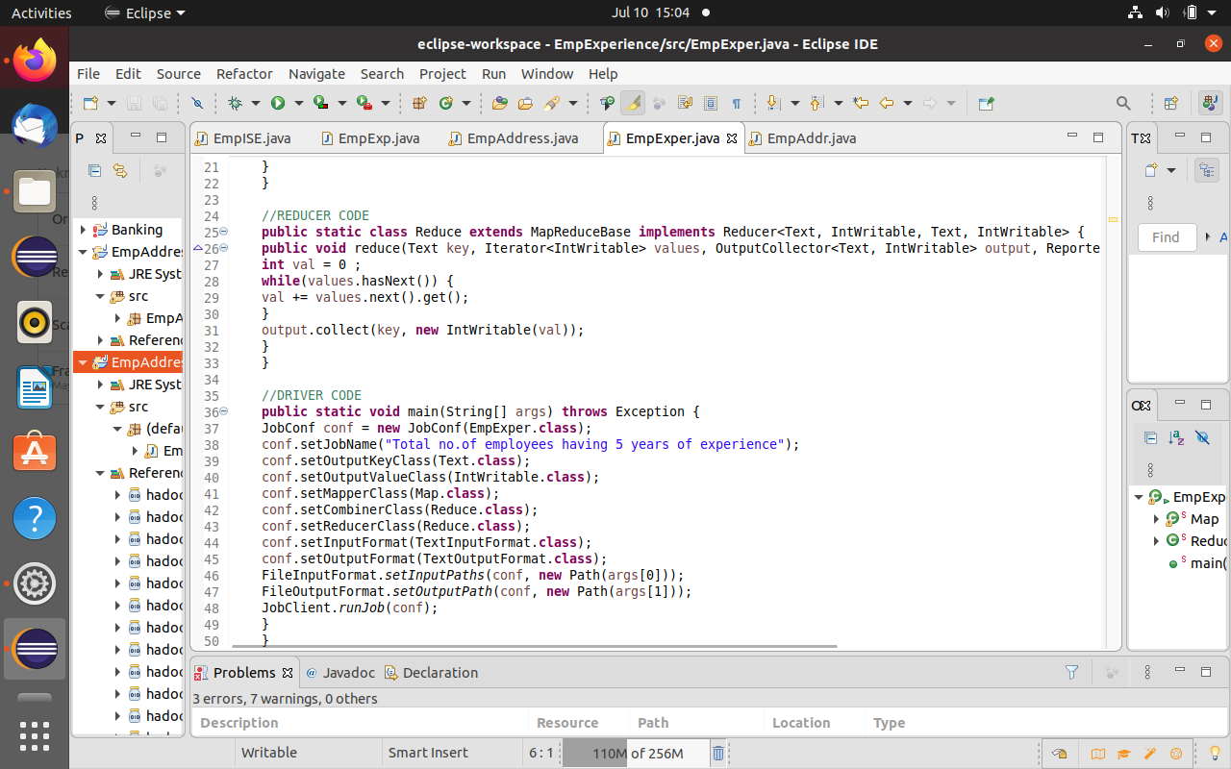

3.EmpAddressBangalore Project -> EmpAddr

import java.io.IOException;

import java.util.*;

import org.apache.hadoop.fs.Path;

import org.apache.hadoop.conf.*;

import org.apache.hadoop.io.*;

import org.apache.hadoop.mapred.*;

import org.apache.hadoop.util.*;

public class EmpAddr {

//Mapper Code

public static class Map extends MapReduceBase implements Mapper<LongWritable, Text, Text, IntWritable> {

private final static IntWritable one = new IntWritable(1);

private Text word = new Text();

public void map(LongWritable key, Text value, OutputCollector<Text, IntWritable> output, Reporter reporter) throws IOException {

String data = value.toString();

String[] Ecount= data.split(",");

if (Ecount[3].equals("Bangalore")) {

output.collect(new Text("Total no.of employees who stays in Bangalore : "), one);

}

}

}

//REDUCER CODE

public static class Reduce extends MapReduceBase implements Reducer<Text, IntWritable, Text, IntWritable> {

public void reduce(Text key, Iterator<IntWritable> values, OutputCollector<Text, IntWritable> output, Reporter reporter) throws IOException { //{little: {1,1}}

int val = 0 ;

while(values.hasNext()) {

val += values.next().get();

}

output.collect(key, new IntWritable(val));

}

}

//DRIVER CODE

public static void main(String[] args) throws Exception {

JobConf conf = new JobConf(EmpAddr.class);

conf.setJobName("Total no.of employees having 5 years of experience");

conf.setOutputKeyClass(Text.class);

conf.setOutputValueClass(IntWritable.class);

conf.setMapperClass(Map.class);

conf.setCombinerClass(Reduce.class);

conf.setReducerClass(Reduce.class);

conf.setInputFormat(TextInputFormat.class);

conf.setOutputFormat(TextOutputFormat.class);

FileInputFormat.setInputPaths(conf, new Path(args[0]));

FileOutputFormat.setOutputPath(conf, new Path(args[1]));

JobClient.runJob(conf);

}

}

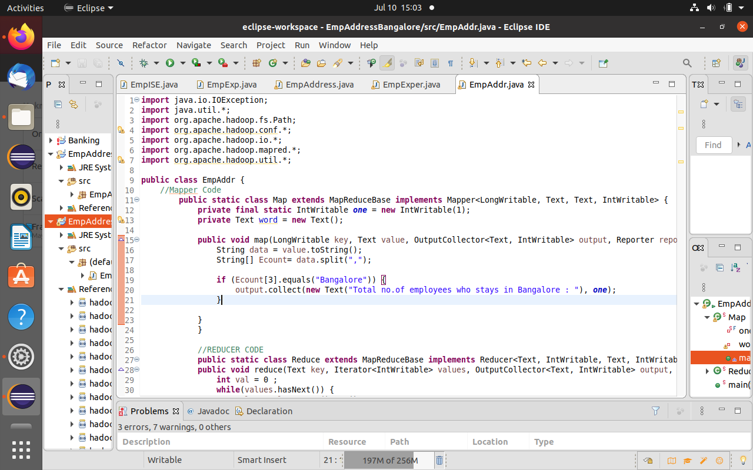

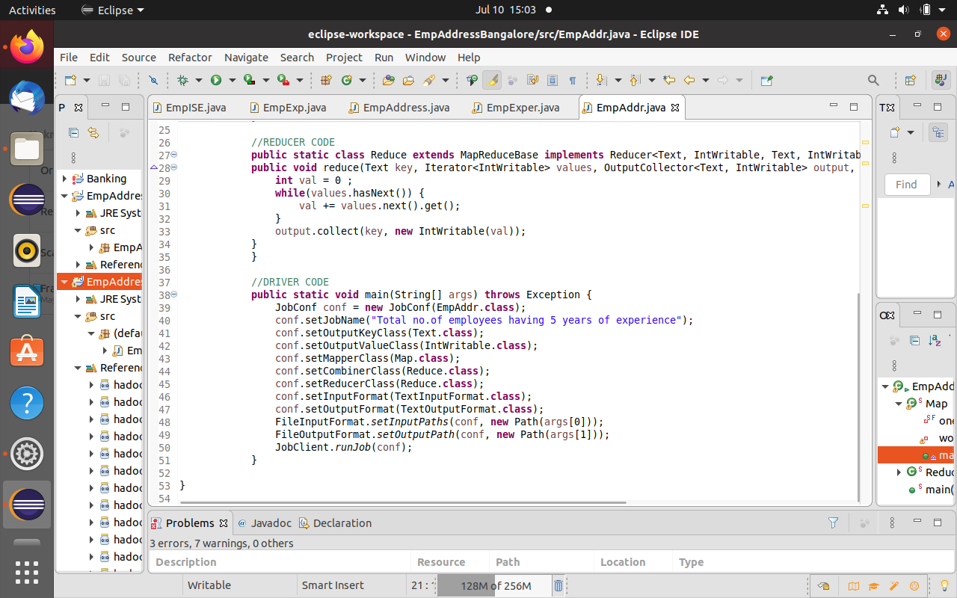

**Hadoop Map-reduce commands and outputs :**

hadoop@hadoop-VirtualBox:~$ su - hdoop

Password:

hdoop@hadoop-VirtualBox:~$ cd hadoop-3.2.1/sbin

hdoop@hadoop-VirtualBox:~/hadoop-3.2.1/sbin$ ./start-all.sh

WARNING: Attempting to start all Apache Hadoop daemons as hdoop in 10 seconds.

WARNING: This is not a recommended production deployment configuration.

WARNING: Use CTRL-C to abort.

Starting namenodes on [localhost]

Starting datanodes

Starting secondary namenodes [hadoop-VirtualBox]

Starting resourcemanager

Starting nodemanagers

hdoop@hadoop-VirtualBox:~/hadoop-3.2.1/sbin$ jps

8192 DataNode

8609 ResourceManager

8737 NodeManager

8364 SecondaryNameNode

8062 NameNode

8894 Jps

hdoop@hadoop-VirtualBox:~$ cd /home/hadoop/Desktop

hdoop@hadoop-VirtualBox:/home/hadoop/Desktop$ ls

dataset.csv EmpExpclass.jar

'Eclipse IDE for Java Developers - 2021-03.desktop' EmpExp.jar

EmpAddressclass.jar EmpISE.jar

EmpAddress.jar Employee.jar

hdoop@hadoop-VirtualBox:~/hadoop-3.2.1/sbin$ pwd

/home/hdoop/hadoop-3.2.1/sbin

hdoop@hadoop-VirtualBox:~/hadoop-3.2.1/sbin$ hadoop fs -mkdir -p /user/hdoop

hdoop@hadoop-VirtualBox:~/hadoop-3.2.1/sbin$ hadoop fs -ls /user

Found 2 items

drwxr-xr-x - hdoop supergroup 0 2021-07-10 12:09 /user/hdoop

drwxr-xr-x - hdoop supergroup 0 2021-07-05 21:50 /user/hive

hdoop@hadoop-VirtualBox:~/hadoop-3.2.1/sbin$ hadoop fs -ls

hdoop@hadoop-VirtualBox:~/hadoop-3.2.1/sbin$ hadoop fs -mkdir -p /user/hdoop/faizah

hdoop@hadoop-VirtualBox:~/hadoop-3.2.1/sbin$ hadoop fs -ls

Found 1 items

drwxr-xr-x - hdoop supergroup 0 2021-07-10 12:11 faizah

hdoop@hadoop-VirtualBox:~/hadoop-3.2.1/sbin$ hadoop fs -copyFromLocal /home/hadoop/Desktop/dataset.csv

2021-07-10 12:11:47,556 INFO sasl.SaslDataTransferClient: SASL encryption trust check: localHostTrusted = false, remoteHostTrusted = false

hdoop@hadoop-VirtualBox:~/hadoop-3.2.1/sbin$ hadoop fs -ls

Found 2 items

-rw-r--r-- 1 hdoop supergroup 823 2021-07-10 12:11 dataset.csv

drwxr-xr-x - hdoop supergroup 0 2021-07-10 12:11 faizah

hdoop@hadoop-VirtualBox:~/hadoop-3.2.1/sbin$ hadoop jar Employee.jar Employee.EmpISE dataset.csv EmpISE.txt

JAR does not exist or is not a normal file: /home/hdoop/hadoop-3.2.1/sbin/Employee.jar

hdoop@hadoop-VirtualBox:~/hadoop-3.2.1/sbin$ hadoop jar Employee.jar EmpISE dataset.csv EmpISE.txt

JAR does not exist or is not a normal file: /home/hdoop/hadoop-3.2.1/sbin/Employee.jar

hdoop@hadoop-VirtualBox:~/hadoop-3.2.1/sbin$

hdoop@hadoop-VirtualBox:~/hadoop-3.2.1/sbin$ hadoop jar Employee.jar EmpISE dataset.csv EmpISE.txt

JAR does not exist or is not a normal file: /home/hdoop/hadoop-3.2.1/sbin/Employee.jar

hdoop@hadoop-VirtualBox:~/hadoop-3.2.1/sbin$ hadoop jar /home/hadoop/Desktop/Employee.jar EmpISE dataset.csv EmpISE.txt

2021-07-10 12:47:43,263 INFO client.RMProxy: Connecting to ResourceManager at /127.0.0.1:8032

2021-07-10 12:47:43,623 INFO client.RMProxy: Connecting to ResourceManager at /127.0.0.1:8032

2021-07-10 12:47:43,933 WARN mapreduce.JobResourceUploader: Hadoop command-line option parsing not performed. Implement the Tool interface and execute your application with ToolRunner to remedy this.

2021-07-10 12:47:43,992 INFO mapreduce.JobResourceUploader: Disabling Erasure Coding for path: /tmp/hadoop-yarn/staging/hdoop/.staging/job_1625897933179_0001

2021-07-10 12:47:44,243 INFO sasl.SaslDataTransferClient: SASL encryption trust check: localHostTrusted = false, remoteHostTrusted = false

2021-07-10 12:47:44,468 INFO mapred.FileInputFormat: Total input files to process : 1

2021-07-10 12:47:44,553 INFO sasl.SaslDataTransferClient: SASL encryption trust check: localHostTrusted = false, remoteHostTrusted = false

2021-07-10 12:47:44,571 WARN hdfs.DataStreamer: Caught exception

java.lang.InterruptedException

at java.lang.Object.wait(Native Method)

at java.lang.Thread.join(Thread.java:1252)

at java.lang.Thread.join(Thread.java:1326)

at org.apache.hadoop.hdfs.DataStreamer.closeResponder(DataStreamer.java:986)

at org.apache.hadoop.hdfs.DataStreamer.endBlock(DataStreamer.java:640)

at org.apache.hadoop.hdfs.DataStreamer.run(DataStreamer.java:810)

2021-07-10 12:47:44,614 INFO sasl.SaslDataTransferClient: SASL encryption trust check: localHostTrusted = false, remoteHostTrusted = false

2021-07-10 12:47:44,639 INFO mapreduce.JobSubmitter: number of splits:2

2021-07-10 12:47:44,926 INFO sasl.SaslDataTransferClient: SASL encryption trust check: localHostTrusted = false, remoteHostTrusted = false

2021-07-10 12:47:44,998 INFO mapreduce.JobSubmitter: Submitting tokens for job: job_1625897933179_0001

2021-07-10 12:47:44,999 INFO mapreduce.JobSubmitter: Executing with tokens: []

2021-07-10 12:47:45,383 INFO conf.Configuration: resource-types.xml not found

2021-07-10 12:47:45,383 INFO resource.ResourceUtils: Unable to find 'resource-types.xml'.

2021-07-10 12:47:45,786 INFO impl.YarnClientImpl: Submitted application application_1625897933179_0001

2021-07-10 12:47:45,989 INFO mapreduce.Job: The url to track the job: http://hadoop-VirtualBox:8088/proxy/application_1625897933179_0001/

2021-07-10 12:47:45,996 INFO mapreduce.Job: Running job: job_1625897933179_0001

2021-07-10 12:47:58,362 INFO mapreduce.Job: Job job_1625897933179_0001 running in uber mode : false

2021-07-10 12:47:58,363 INFO mapreduce.Job: map 0% reduce 0%

2021-07-10 12:48:09,554 INFO mapreduce.Job: map 100% reduce 0%

2021-07-10 12:48:16,638 INFO mapreduce.Job: map 100% reduce 100%

2021-07-10 12:48:17,664 INFO mapreduce.Job: Job job_1625897933179_0001 completed successfully

2021-07-10 12:48:17,891 INFO mapreduce.Job: Counters: 54

File System Counters

FILE: Number of bytes read=120

FILE: Number of bytes written=677699

FILE: Number of read operations=0

FILE: Number of large read operations=0

FILE: Number of write operations=0

HDFS: Number of bytes read=1427

HDFS: Number of bytes written=53

HDFS: Number of read operations=11

HDFS: Number of large read operations=0

HDFS: Number of write operations=2

HDFS: Number of bytes read erasure-coded=0

Job Counters

Launched map tasks=2

Launched reduce tasks=1

Data-local map tasks=2

Total time spent by all maps in occupied slots (ms)=17602

Total time spent by all reduces in occupied slots (ms)=4771

Total time spent by all map tasks (ms)=17602

Total time spent by all reduce tasks (ms)=4771

Total vcore-milliseconds taken by all map tasks=17602

Total vcore-milliseconds taken by all reduce tasks=4771

Total megabyte-milliseconds taken by all map tasks=18024448

Total megabyte-milliseconds taken by all reduce tasks=4885504

Map-Reduce Framework

Map input records=25

Map output records=8

Map output bytes=440

Map output materialized bytes=126

Input split bytes=192

Combine input records=8

Combine output records=2

Reduce input groups=1

Reduce shuffle bytes=126

Reduce input records=2

Reduce output records=1

Spilled Records=4

Shuffled Maps =2

Failed Shuffles=0

Merged Map outputs=2

GC time elapsed (ms)=379

CPU time spent (ms)=1620

Physical memory (bytes) snapshot=537788416

Virtual memory (bytes) snapshot=7447535616

Total committed heap usage (bytes)=355999744

Peak Map Physical memory (bytes)=211656704

Peak Map Virtual memory (bytes)=2479611904

Peak Reduce Physical memory (bytes)=115912704

Peak Reduce Virtual memory (bytes)=2488311808

Shuffle Errors

BAD_ID=0

CONNECTION=0

IO_ERROR=0

WRONG_LENGTH=0

WRONG_MAP=0

WRONG_REDUCE=0

File Input Format Counters

Bytes Read=1235

File Output Format Counters

Bytes Written=53

hdoop@hadoop-VirtualBox:~/hadoop-3.2.1/sbin$ hadoop fs -ls EmpISE.txt

Found 2 items

-rw-r--r-- 1 hdoop supergroup 0 2021-07-10 12:48 EmpISE.txt/_SUCCESS

-rw-r--r-- 1 hdoop supergroup 53 2021-07-10 12:48 EmpISE.txt/part-00000

hdoop@hadoop-VirtualBox:~/hadoop-3.2.1/sbin$ hadoop fs -cat EmpISE.txt/part-00000

2021-07-10 12:49:07,491 INFO sasl.SaslDataTransferClient: SASL encryption trust check: localHostTrusted = false, remoteHostTrusted = false

Total no.of employees working in ISE Department : 8

hdoop@hadoop-VirtualBox:~/hadoop-3.2.1/sbin$

hdoop@hadoop-VirtualBox:~/hadoop-3.2.1/sbin$

hdoop@hadoop-VirtualBox:~/hadoop-3.2.1/sbin$ hadoop jar /home/hadoop/Desktop/EmpExperience.jar EmpExper dataset.csv EmpExp.txt

2021-07-10 13:16:38,066 INFO client.RMProxy: Connecting to ResourceManager at /127.0.0.1:8032

2021-07-10 13:16:38,543 INFO client.RMProxy: Connecting to ResourceManager at /127.0.0.1:8032

2021-07-10 13:16:38,979 WARN mapreduce.JobResourceUploader: Hadoop command-line option parsing not performed. Implement the Tool interface and execute your application with ToolRunner to remedy this.

2021-07-10 13:16:39,055 INFO mapreduce.JobResourceUploader: Disabling Erasure Coding for path: /tmp/hadoop-yarn/staging/hdoop/.staging/job_1625897933179_0002

2021-07-10 13:16:39,317 INFO sasl.SaslDataTransferClient: SASL encryption trust check: localHostTrusted = false, remoteHostTrusted = false

2021-07-10 13:16:39,589 INFO mapred.FileInputFormat: Total input files to process : 1

2021-07-10 13:16:39,698 INFO sasl.SaslDataTransferClient: SASL encryption trust check: localHostTrusted = false, remoteHostTrusted = false

2021-07-10 13:16:39,804 INFO sasl.SaslDataTransferClient: SASL encryption trust check: localHostTrusted = false, remoteHostTrusted = false

2021-07-10 13:16:39,858 INFO mapreduce.JobSubmitter: number of splits:2

2021-07-10 13:16:40,222 INFO sasl.SaslDataTransferClient: SASL encryption trust check: localHostTrusted = false, remoteHostTrusted = false

2021-07-10 13:16:40,316 INFO mapreduce.JobSubmitter: Submitting tokens for job: job_1625897933179_0002

2021-07-10 13:16:40,317 INFO mapreduce.JobSubmitter: Executing with tokens: []

2021-07-10 13:16:40,763 INFO conf.Configuration: resource-types.xml not found

2021-07-10 13:16:40,763 INFO resource.ResourceUtils: Unable to find 'resource-types.xml'.

2021-07-10 13:16:40,920 INFO impl.YarnClientImpl: Submitted application application_1625897933179_0002

2021-07-10 13:16:41,044 INFO mapreduce.Job: The url to track the job: http://hadoop-VirtualBox:8088/proxy/application_1625897933179_0002/

2021-07-10 13:16:41,050 INFO mapreduce.Job: Running job: job_1625897933179_0002

2021-07-10 13:16:51,614 INFO mapreduce.Job: Job job_1625897933179_0002 running in uber mode : false

2021-07-10 13:16:51,617 INFO mapreduce.Job: map 0% reduce 0%

2021-07-10 13:17:04,875 INFO mapreduce.Job: map 100% reduce 0%

2021-07-10 13:17:13,048 INFO mapreduce.Job: map 100% reduce 100%

2021-07-10 13:17:14,071 INFO mapreduce.Job: Job job_1625897933179_0002 completed successfully

2021-07-10 13:17:14,368 INFO mapreduce.Job: Counters: 54

File System Counters

FILE: Number of bytes read=126

FILE: Number of bytes written=677738

FILE: Number of read operations=0

FILE: Number of large read operations=0

FILE: Number of write operations=0

HDFS: Number of bytes read=1427

HDFS: Number of bytes written=56

HDFS: Number of read operations=11

HDFS: Number of large read operations=0

HDFS: Number of write operations=2

HDFS: Number of bytes read erasure-coded=0

Job Counters

Launched map tasks=2

Launched reduce tasks=1

Data-local map tasks=2

Total time spent by all maps in occupied slots (ms)=22438

Total time spent by all reduces in occupied slots (ms)=5547

Total time spent by all map tasks (ms)=22438

Total time spent by all reduce tasks (ms)=5547

Total vcore-milliseconds taken by all map tasks=22438

Total vcore-milliseconds taken by all reduce tasks=5547

Total megabyte-milliseconds taken by all map tasks=22976512

Total megabyte-milliseconds taken by all reduce tasks=5680128

Map-Reduce Framework

Map input records=25

Map output records=8

Map output bytes=464

Map output materialized bytes=132

Input split bytes=192

Combine input records=8

Combine output records=2

Reduce input groups=1

Reduce shuffle bytes=132

Reduce input records=2

Reduce output records=1

Spilled Records=4

Shuffled Maps =2

Failed Shuffles=0

Merged Map outputs=2

GC time elapsed (ms)=361

CPU time spent (ms)=1760

Physical memory (bytes) snapshot=510971904

Virtual memory (bytes) snapshot=7447531520

Total committed heap usage (bytes)=355999744

Peak Map Physical memory (bytes)=197791744

Peak Map Virtual memory (bytes)=2479611904

Peak Reduce Physical memory (bytes)=115412992

Peak Reduce Virtual memory (bytes)=2488307712

Shuffle Errors

BAD_ID=0

CONNECTION=0

IO_ERROR=0

WRONG_LENGTH=0

WRONG_MAP=0

WRONG_REDUCE=0

File Input Format Counters

Bytes Read=1235

File Output Format Counters

Bytes Written=56

hdoop@hadoop-VirtualBox:~/hadoop-3.2.1/sbin$ hadoop fs -ls EmpExp.txt

Found 2 items

-rw-r--r-- 1 hdoop supergroup 0 2021-07-10 13:17 EmpExp.txt/_SUCCESS

-rw-r--r-- 1 hdoop supergroup 56 2021-07-10 13:17 EmpExp.txt/part-00000

hdoop@hadoop-VirtualBox:~/hadoop-3.2.1/sbin$ hadoop fs -cat Empexp.txt/part-00000

cat: `Empexp.txt/part-00000': No such file or directory

hdoop@hadoop-VirtualBox:~/hadoop-3.2.1/sbin$ hadoop fs -cat EmpExp.txt/part-00000

2021-07-10 13:18:08,341 INFO sasl.SaslDataTransferClient: SASL encryption trust check: localHostTrusted = false, remoteHostTrusted = false

Total no.of employees having 5 years of experience : 8

hdoop@hadoop-VirtualBox:~/hadoop-3.2.1/sbin$ hadoop jar /home/hadoop/Desktop/EmpAddressBangalore.jar EmpAddr dataset.csv EmpAdd.txt

2021-07-10 13:33:04,191 INFO client.RMProxy: Connecting to ResourceManager at /127.0.0.1:8032

2021-07-10 13:33:04,664 INFO client.RMProxy: Connecting to ResourceManager at /127.0.0.1:8032

2021-07-10 13:33:04,957 WARN mapreduce.JobResourceUploader: Hadoop command-line option parsing not performed. Implement the Tool interface and execute your application with ToolRunner to remedy this.

2021-07-10 13:33:05,023 INFO mapreduce.JobResourceUploader: Disabling Erasure Coding for path: /tmp/hadoop-yarn/staging/hdoop/.staging/job_1625897933179_0003

2021-07-10 13:33:05,312 INFO sasl.SaslDataTransferClient: SASL encryption trust check: localHostTrusted = false, remoteHostTrusted = false

2021-07-10 13:33:05,609 INFO mapred.FileInputFormat: Total input files to process : 1

2021-07-10 13:33:05,693 INFO sasl.SaslDataTransferClient: SASL encryption trust check: localHostTrusted = false, remoteHostTrusted = false

2021-07-10 13:33:05,766 INFO sasl.SaslDataTransferClient: SASL encryption trust check: localHostTrusted = false, remoteHostTrusted = false

2021-07-10 13:33:05,794 INFO mapreduce.JobSubmitter: number of splits:2

2021-07-10 13:33:06,038 INFO sasl.SaslDataTransferClient: SASL encryption trust check: localHostTrusted = false, remoteHostTrusted = false

2021-07-10 13:33:06,127 INFO mapreduce.JobSubmitter: Submitting tokens for job: job_1625897933179_0003

2021-07-10 13:33:06,127 INFO mapreduce.JobSubmitter: Executing with tokens: []

2021-07-10 13:33:06,532 INFO conf.Configuration: resource-types.xml not found

2021-07-10 13:33:06,533 INFO resource.ResourceUtils: Unable to find 'resource-types.xml'.

2021-07-10 13:33:06,658 INFO impl.YarnClientImpl: Submitted application application_1625897933179_0003

2021-07-10 13:33:06,744 INFO mapreduce.Job: The url to track the job: http://hadoop-VirtualBox:8088/proxy/application_1625897933179_0003/

2021-07-10 13:33:06,749 INFO mapreduce.Job: Running job: job_1625897933179_0003

2021-07-10 13:33:17,074 INFO mapreduce.Job: Job job_1625897933179_0003 running in uber mode : false

2021-07-10 13:33:17,078 INFO mapreduce.Job: map 0% reduce 0%

2021-07-10 13:33:27,336 INFO mapreduce.Job: map 50% reduce 0%

2021-07-10 13:33:28,433 INFO mapreduce.Job: map 100% reduce 0%

2021-07-10 13:33:35,550 INFO mapreduce.Job: map 100% reduce 100%

2021-07-10 13:33:36,575 INFO mapreduce.Job: Job job_1625897933179_0003 completed successfully

2021-07-10 13:33:36,795 INFO mapreduce.Job: Counters: 54

File System Counters

FILE: Number of bytes read=114

FILE: Number of bytes written=677705

FILE: Number of read operations=0

FILE: Number of large read operations=0

FILE: Number of write operations=0

HDFS: Number of bytes read=1427

HDFS: Number of bytes written=50

HDFS: Number of read operations=11

HDFS: Number of large read operations=0

HDFS: Number of write operations=2

HDFS: Number of bytes read erasure-coded=0

Job Counters

Launched map tasks=2

Launched reduce tasks=1

Data-local map tasks=2

Total time spent by all maps in occupied slots (ms)=17366

Total time spent by all reduces in occupied slots (ms)=4823

Total time spent by all map tasks (ms)=17366

Total time spent by all reduce tasks (ms)=4823

Total vcore-milliseconds taken by all map tasks=17366

Total vcore-milliseconds taken by all reduce tasks=4823

Total megabyte-milliseconds taken by all map tasks=17782784

Total megabyte-milliseconds taken by all reduce tasks=4938752

Map-Reduce Framework

Map input records=25

Map output records=7

Map output bytes=364

Map output materialized bytes=120

Input split bytes=192

Combine input records=7

Combine output records=2

Reduce input groups=1

Reduce shuffle bytes=120

Reduce input records=2

Reduce output records=1

Spilled Records=4

Shuffled Maps =2

Failed Shuffles=0

Merged Map outputs=2

GC time elapsed (ms)=417

CPU time spent (ms)=1650

Physical memory (bytes) snapshot=549564416

Virtual memory (bytes) snapshot=7447531520

Total committed heap usage (bytes)=355999744

Peak Map Physical memory (bytes)=217133056

Peak Map Virtual memory (bytes)=2479611904

Peak Reduce Physical memory (bytes)=115679232

Peak Reduce Virtual memory (bytes)=2488307712

Shuffle Errors

BAD_ID=0

CONNECTION=0

IO_ERROR=0

WRONG_LENGTH=0

WRONG_MAP=0

WRONG_REDUCE=0

File Input Format Counters

Bytes Read=1235

File Output Format Counters

Bytes Written=50

hdoop@hadoop-VirtualBox:~/hadoop-3.2.1/sbin$ hadoop fs -ls EmpAdd.txt

Found 2 items

-rw-r--r-- 1 hdoop supergroup 0 2021-07-10 13:33 EmpAdd.txt/_SUCCESS

-rw-r--r-- 1 hdoop supergroup 50 2021-07-10 13:33 EmpAdd.txt/part-00000

hdoop@hadoop-VirtualBox:~/hadoop-3.2.1/sbin$ hadoop fs -cat EmpAdd.txt/part-00000

2021-07-10 13:34:07,326 INFO sasl.SaslDataTransferClient: SASL encryption trust check: localHostTrusted = false, remoteHostTrusted = false

Total no.of employees who stays in Bangalore : 7

hdoop@hadoop-VirtualBox:~/hadoop-3.2.1/sbin$

HADOOP MAP REDUCE SCREENSHOTS :

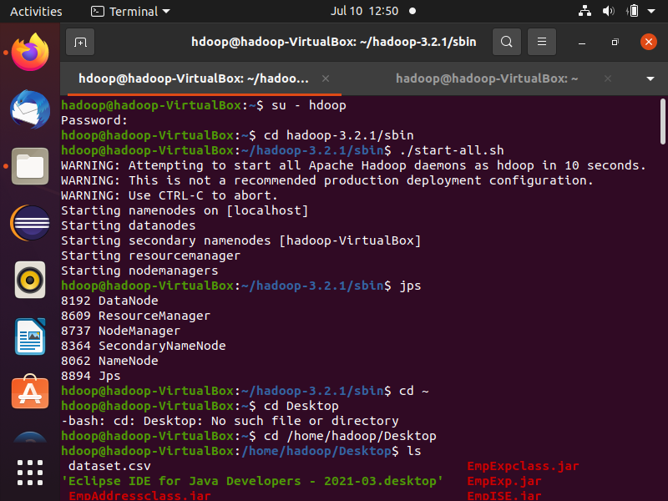

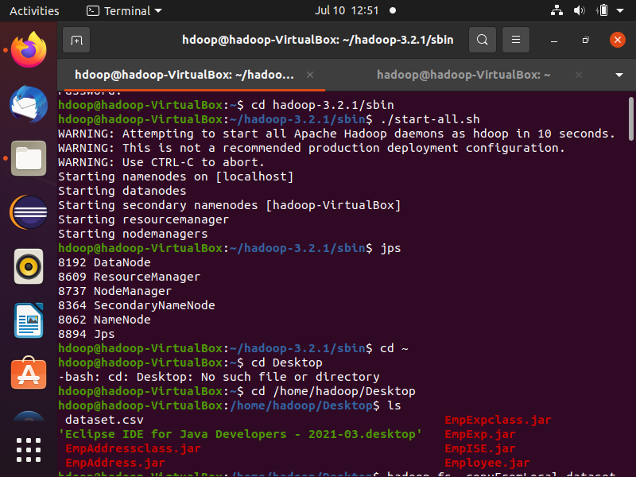

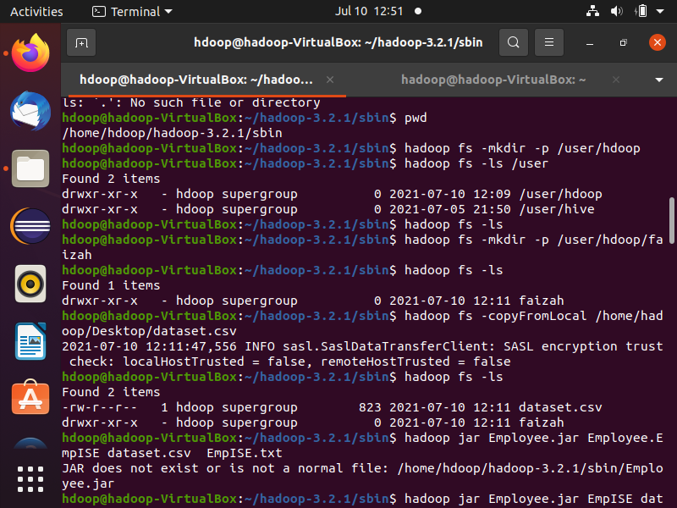

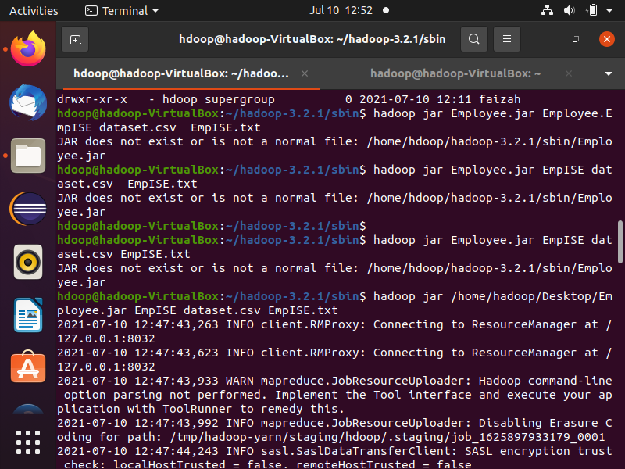

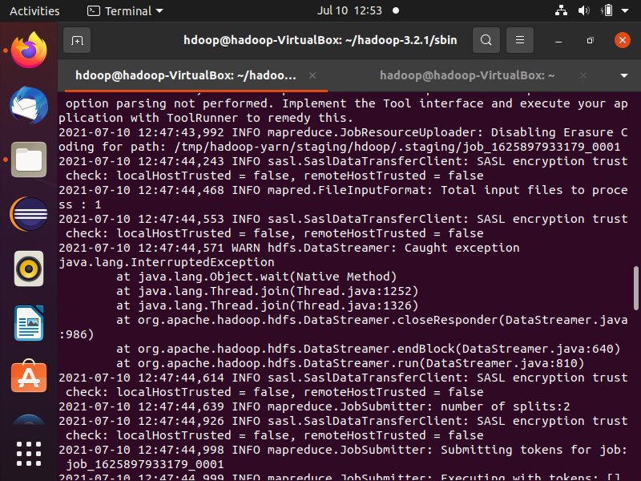

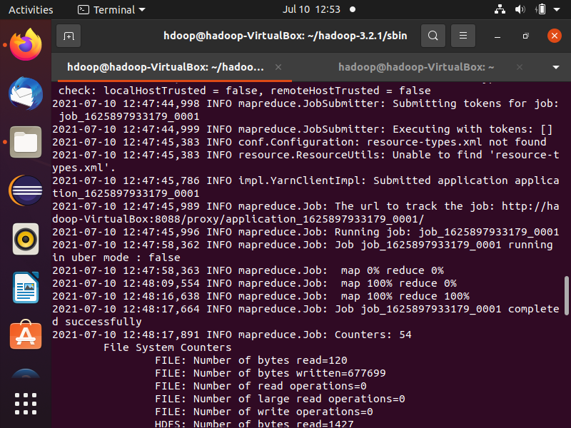

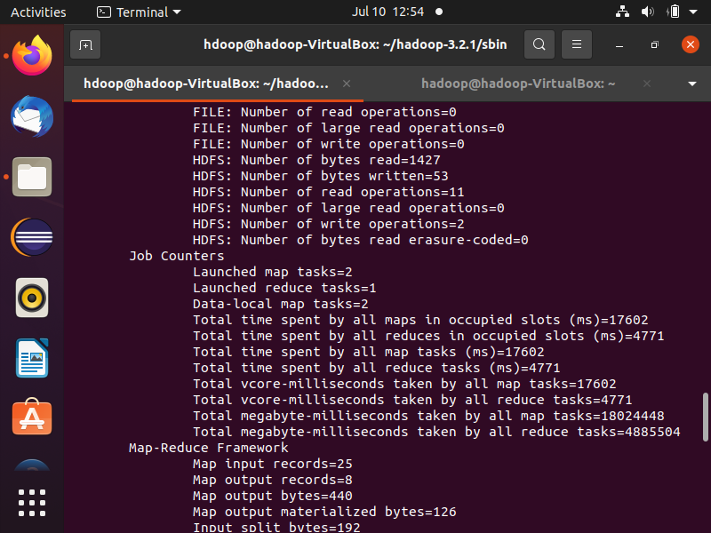

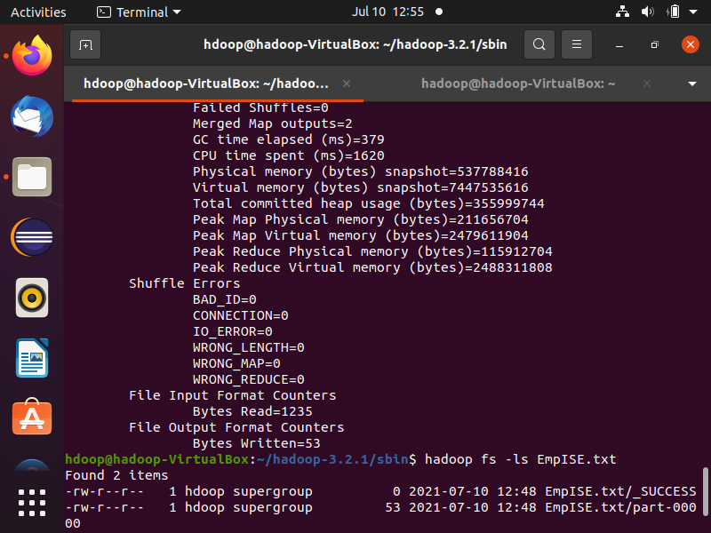

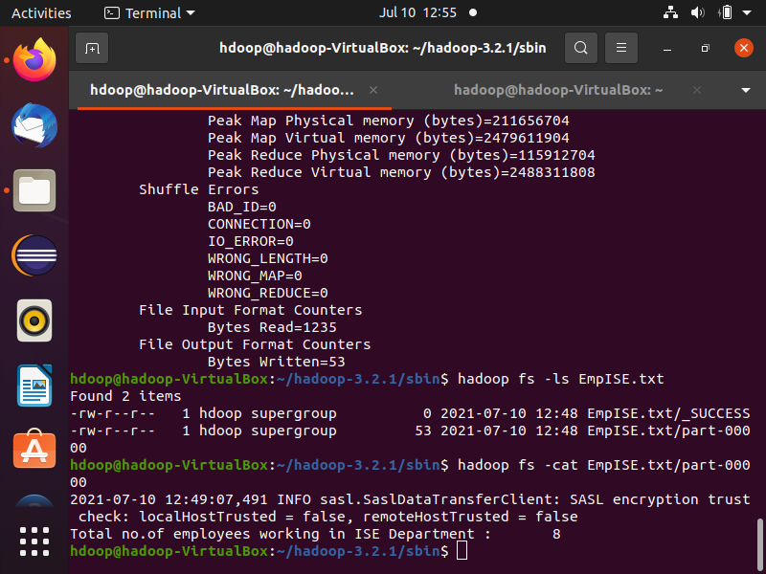

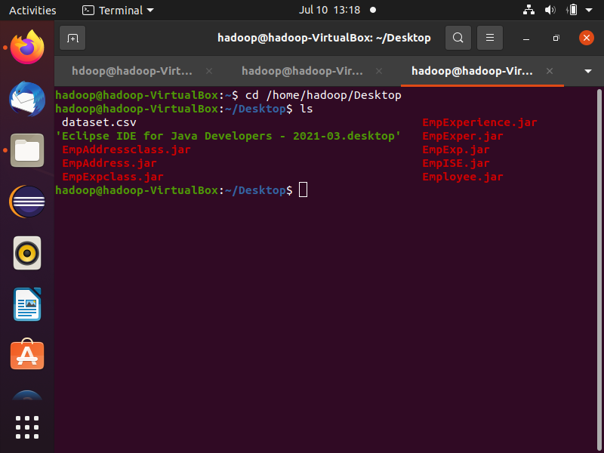

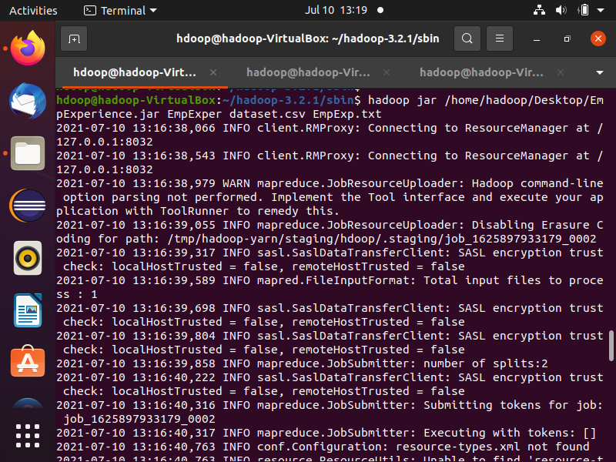

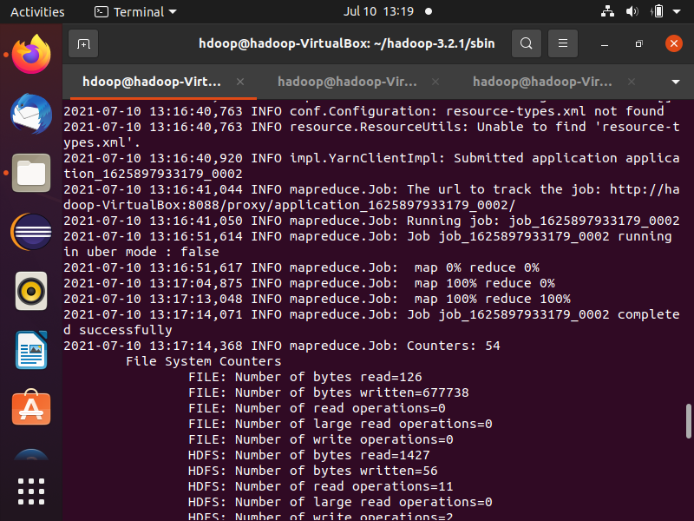

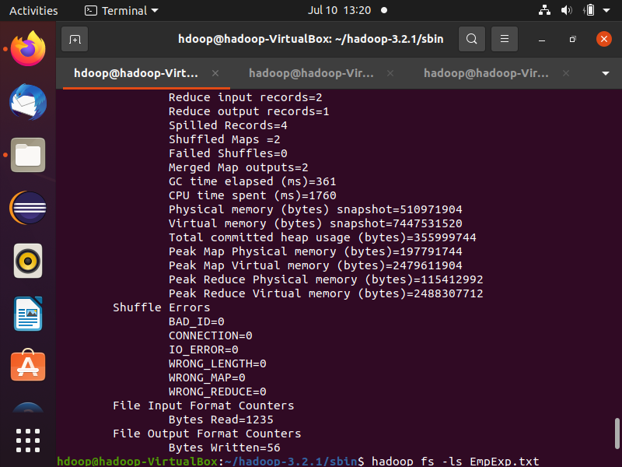

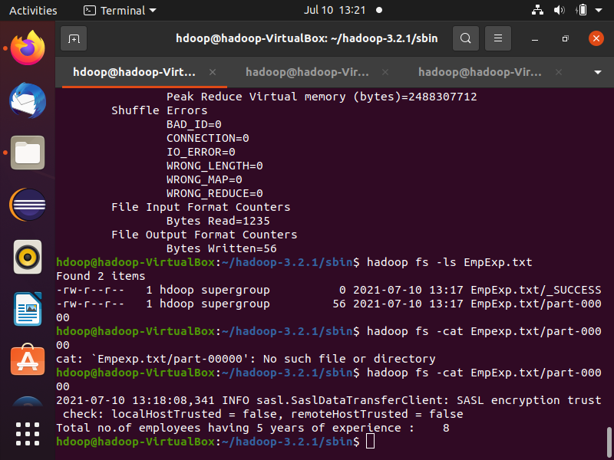



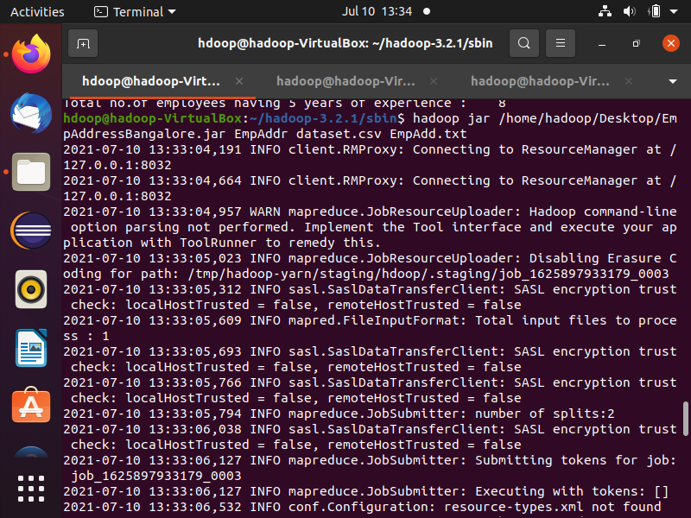

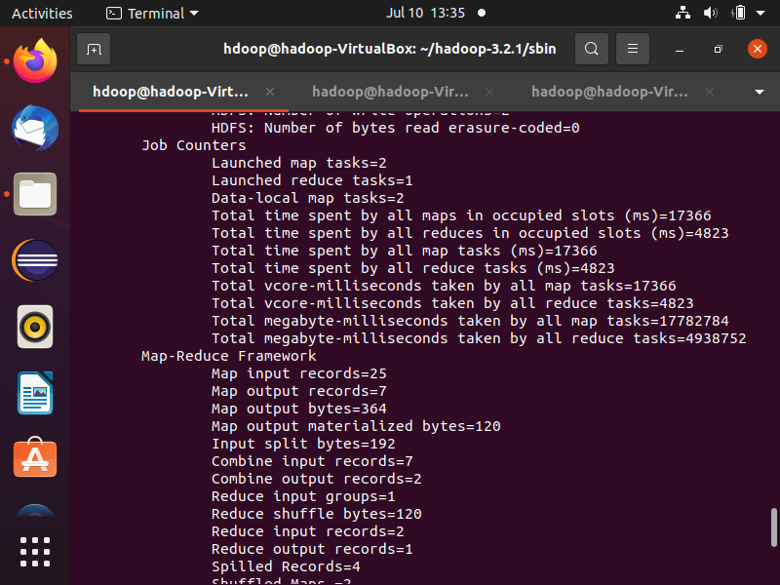

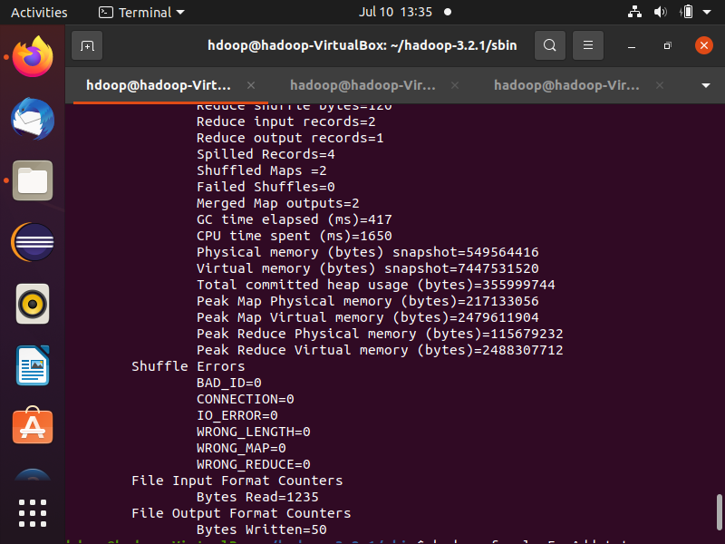

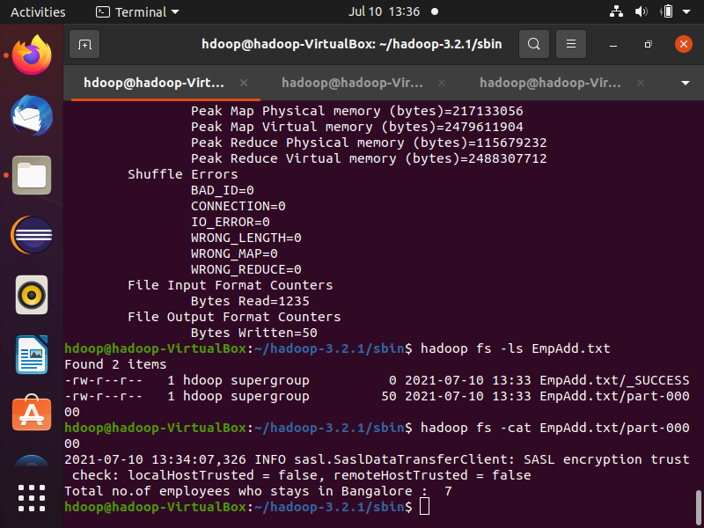

**Exercise-II**

Use the above dataset in .csv file and create a database called as EmployeeDB. Create a table under the database called as Employee using

HIVEQL.

Use the HiveQL language to perform the following Query based Map-reduce operations,

1. **Insert 5 records using INSERT command.**

hive> create database if not exists EmployeeDB;

OK

Time taken: 0.081 seconds

hive> show databases;

OK

bank_hive

default

employeedb

Time taken: 0.035 seconds, Fetched: 3 row(s)

hive> use employeedb;

OK

Time taken: 0.049 seconds

hive> create table employee(name string,ssn int,salary int,address string,dname string,exp int) row format delimited fields terminated by ",";

OK

Time taken: 0.136 seconds

hive> show tables;

OK

employee

Time taken: 0.06 seconds, Fetched: 1 row(s)

hive> insert into employee values("Kavya",5000,60000,"Bangalore","ISE",3),("Lishel",5001,25000,"Mumbai","CSE",6),("Chavi",5002,55000,"Bangalore","ISE",4),("Jothsna",5003,35000,"Hyderabad","CSE",7),("Aishwarya",5004,80000,"Pune","ECE",2);

hive> select * from employee;

OK

Kavya 5000 60000 Bangalore ISE 3

Lishel 5001 25000 Mumbai CSE 6

Chavi 5002 55000 Bangalore ISE 4

Jothsna 5003 35000 Hyderabad CSE 7

Aishwarya 5004 80000 Pune ECE 2

Time taken: 0.245 seconds, Fetched: 5 row(s)

Output screenshots :

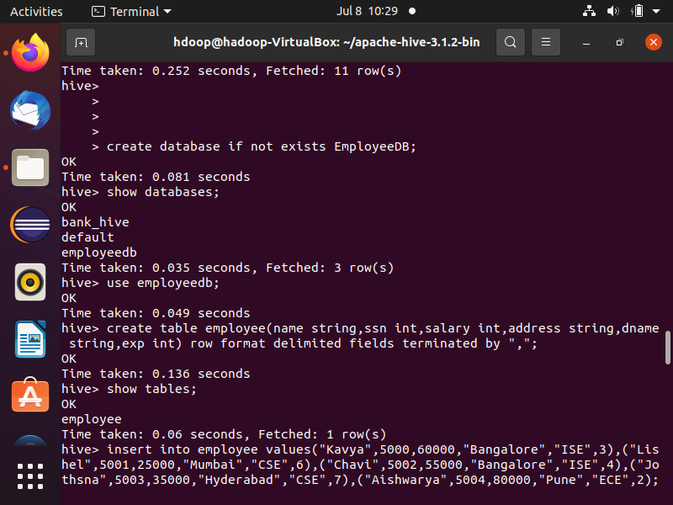

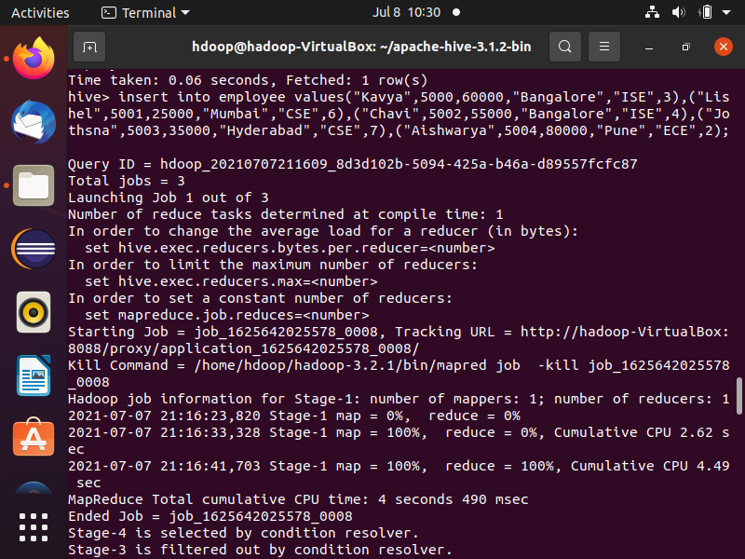

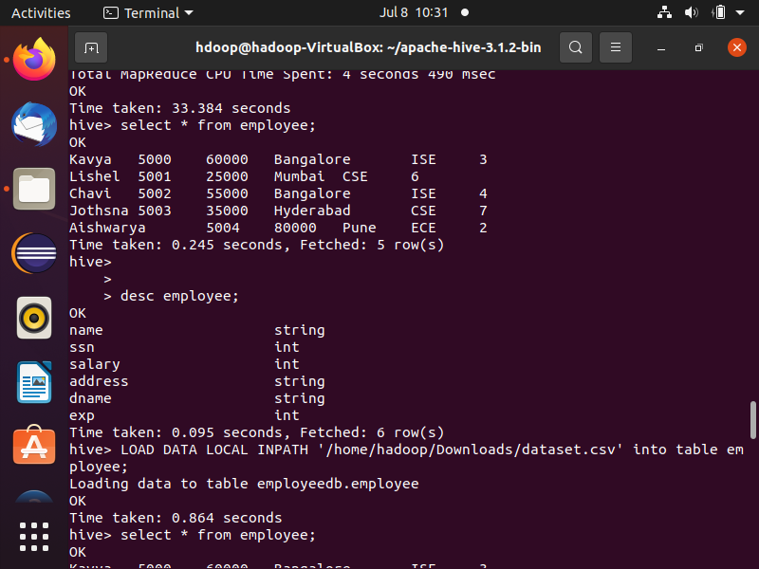

*dataset in .csv file loaded into employee table :-*

hive> LOAD DATA LOCAL INPATH '/home/hadoop/Downloads/dataset.csv' into table employee;

Loading data to table employeedb.employee

OK

Time taken: 0.864 seconds

hive> select * from employee;

OK

Kavya 5000 60000 Bangalore ISE 3

Lishel 5001 25000 Mumbai CSE 6

Chavi 5002 55000 Bangalore ISE 4

Jothsna 5003 35000 Hyderabad CSE 7

Aishwarya 5004 80000 Pune ECE 2

Anusha 6747 70000 Bangalore ISE 5

Avani 4325 30000 Kerala CSE 3

Deepti 7901 58000 Delhi ISE 5

Khushi 2135 25000 Punjab ECE 2

Monika 3984 67000 Kanpur EEE 4

Vanditha 1299 43000 Mumbai ME 6

Gaurav 7733 21000 Rajasthan CSE 7

Anjali 5231 65000 Bangalore ISE 5

Namitha 1177 54000 Pune ECE 4

Ajay 3662 73000 Chennai EEE 6

Akash 9815 20000 Bangalore ISE 5

Darshan 8000 45000 Kolkata CSE 8

Anish 3712 35000 Patna AE 2

Nandan 8868 15000 Bhopal TC 3

Purnima 6734 67000 Bangalore ISE 5

Sharada 4599 34000 Indore CSE 2

Pratik 2001 75000 Bangalore ISE 5

Pooja 6021 28000 Shimla EEE 4

Vikas 4378 32000 Agra CSE 2

Keerthi 1008 65000 Bangalore ISE 5

Sahana 4289 26000 Mangalore EEE 4

Deepak 6710 77000 Coimbatore ECE 6

Ujwal 3011 37000 Kochi CSE 4

Nithin 7888 32000 Goa EEE 3

Karthik 1671 80000 Bangalore ISE 5

Time taken: 0.275 seconds, Fetched: 30 row(s)



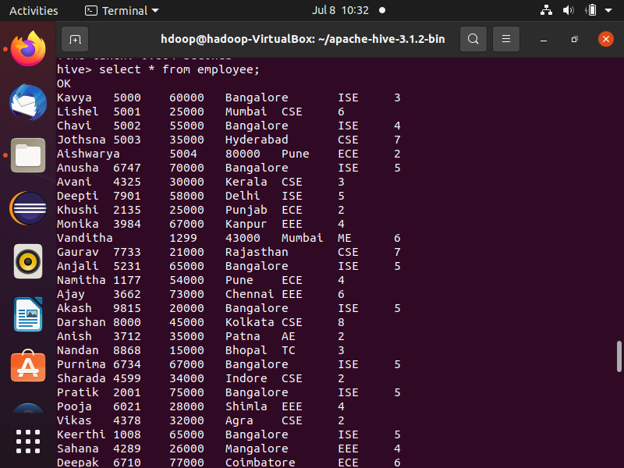

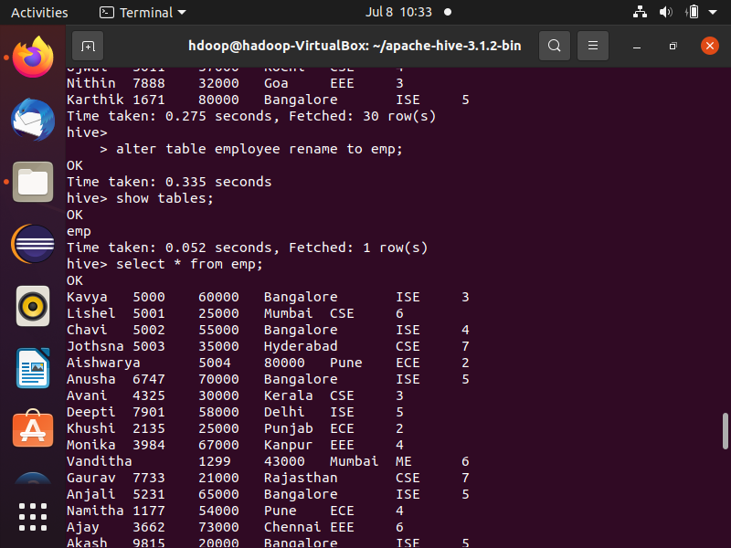

**2. Demonstrate the Alter command for the following cases,**

**a. Rename the table name to “Emp”.**

hive> alter table employee rename to emp;

OK

Time taken: 0.335 seconds

hive> show tables;

OK

emp

Time taken: 0.052 seconds, Fetched: 1 row(s)

hive> select * from emp;

OK

Output screenshots :



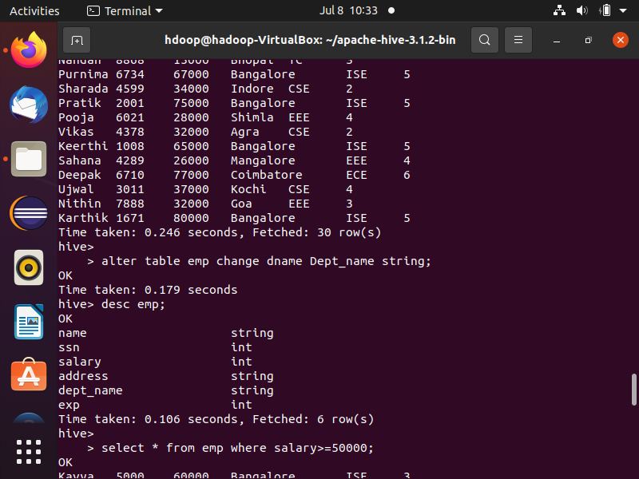

**b. Rename the column name “Dname” to “Dept_name”.**

hive> alter table emp change dname Dept_name string;

OK

Time taken: 0.179 seconds

hive> desc emp;

OK

name string

ssn int

salary int

address string

dept_name string

exp int

Time taken: 0.106 seconds, Fetched: 6 row(s)

Output screenshots :



**3.Retrieve all the employees who’s salary is not less than 50000.**

hive> select * from emp where salary>=50000;

OK

Output screenshots :

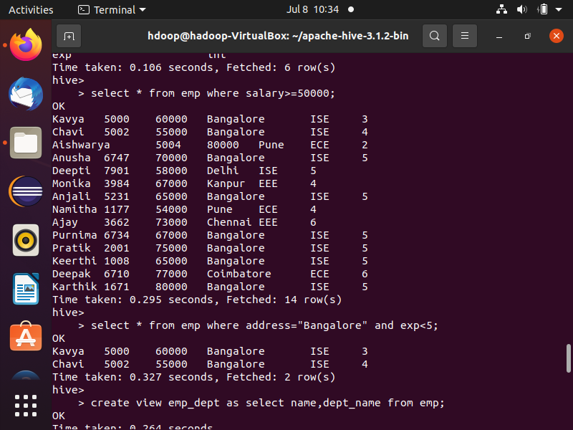

**4. Extract all employees who live in Bangalore but having less than 5 years of experience**

hive> select * from emp where address="Bangalore" and exp<5;

OK



**5. Create separate view containing Name, Dept_name of employees**

hive> create view emp_dept as select name,dept_name from emp;

OK

Time taken: 0.264 seconds

hive> show tables;

OK

emp

emp_dept

Time taken: 0.048 seconds, Fetched: 2 row(s)

hive> select * from emp_dept;

OK

Output screenshots :

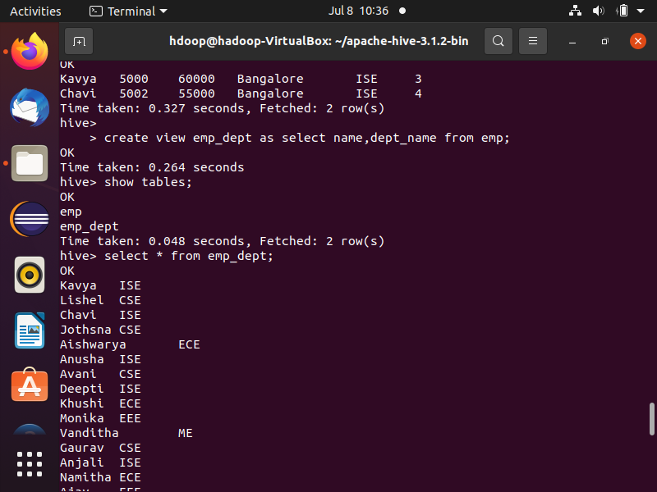

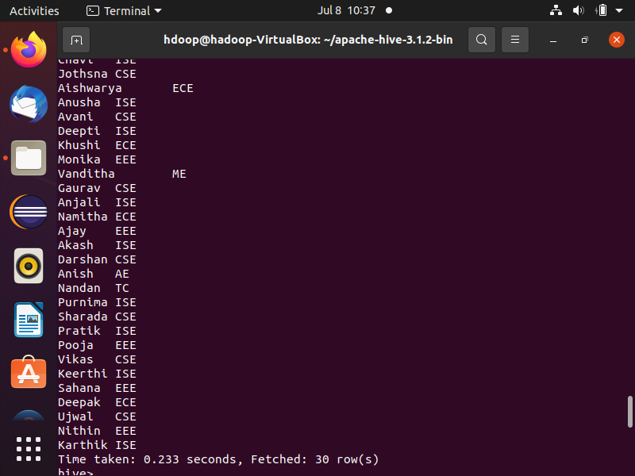

**6. Display Name and SSN and use group by SSN and order by Name**

hive> select name,ssn from emp group by ssn,name order by name;

Output screenshots :

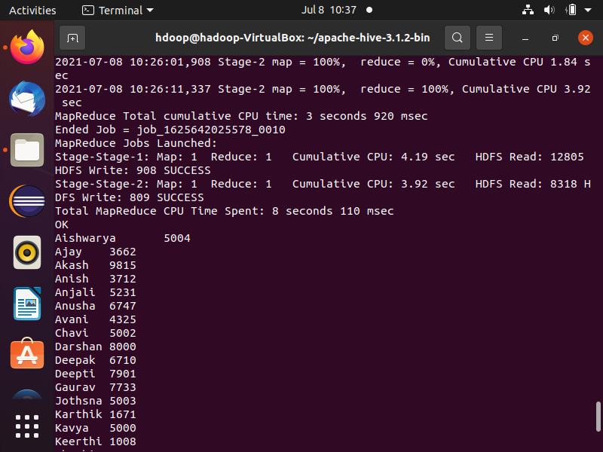

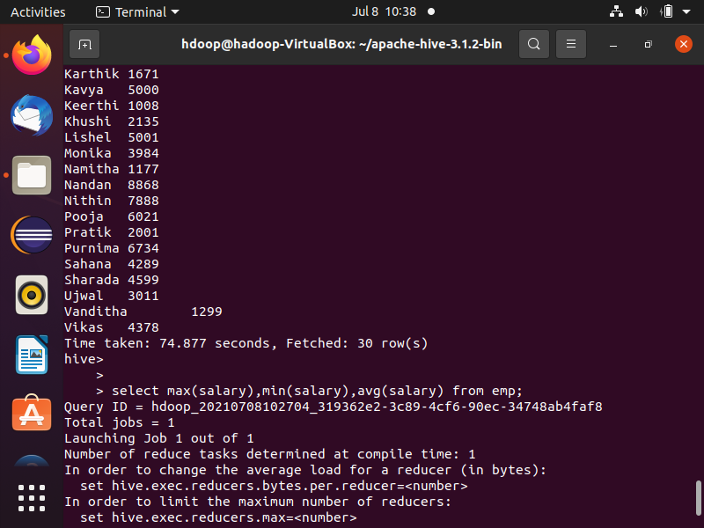

**7. Retrieve Maximum salary, minimum salary and Average salary of the employees**

hive> select max(salary),min(salary),avg(salary) from emp;

Output screenshots :



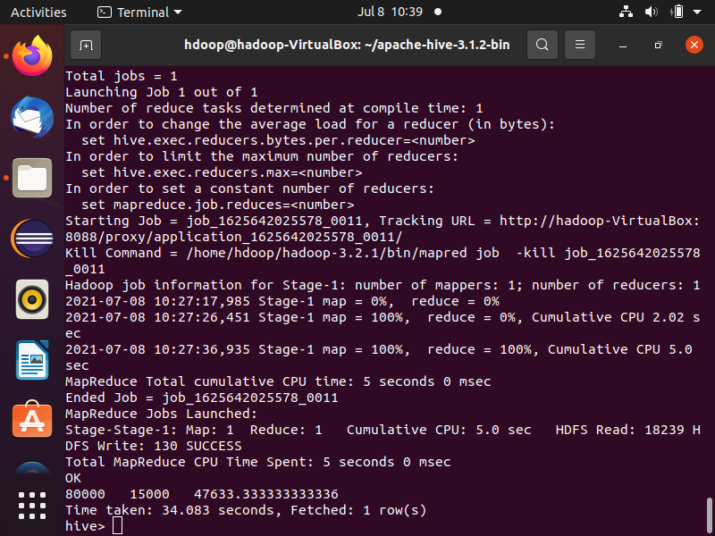

**8. Create Another table called Department with the following fields (Dname = Dept_name and perform the following joins**

**(outer, left outer, right outer) over Dname**

|  |
| --- |
| **Dno Dname** |
| **6 ISE** |

Outer join :-

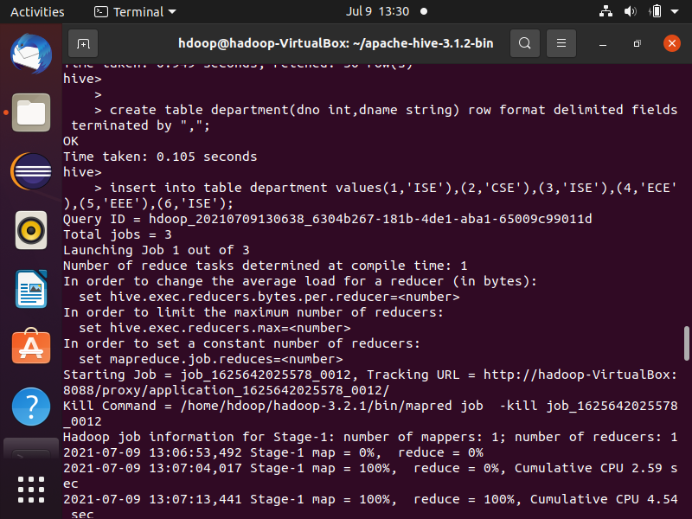

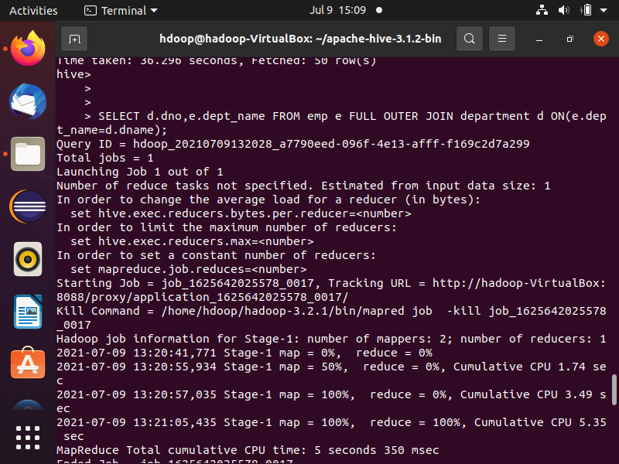

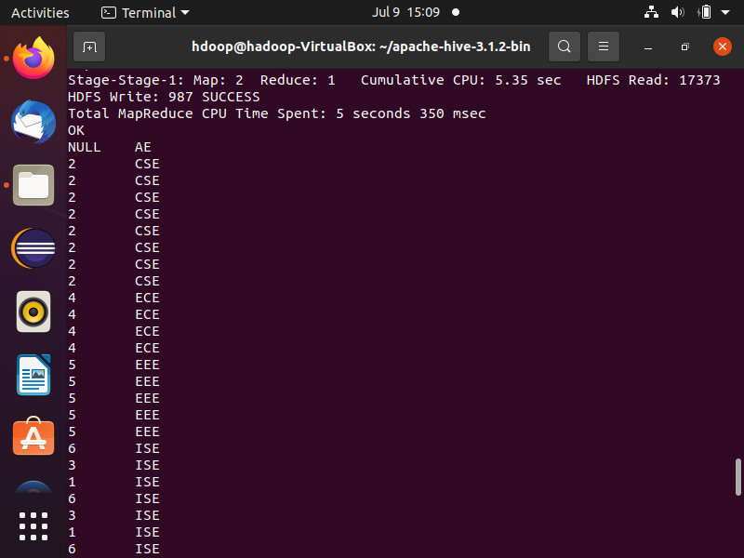

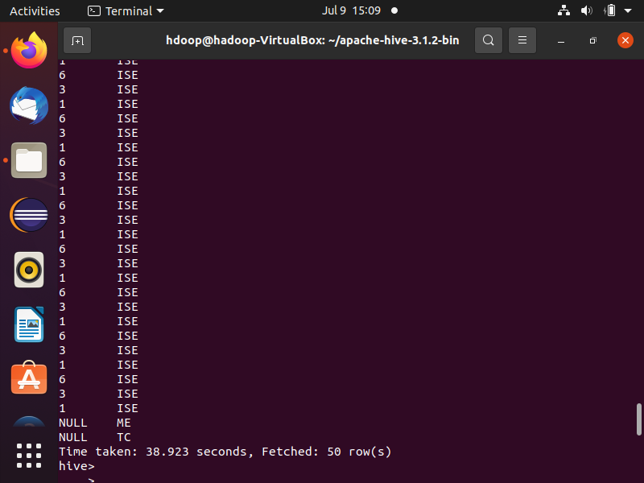

Left outer join :-

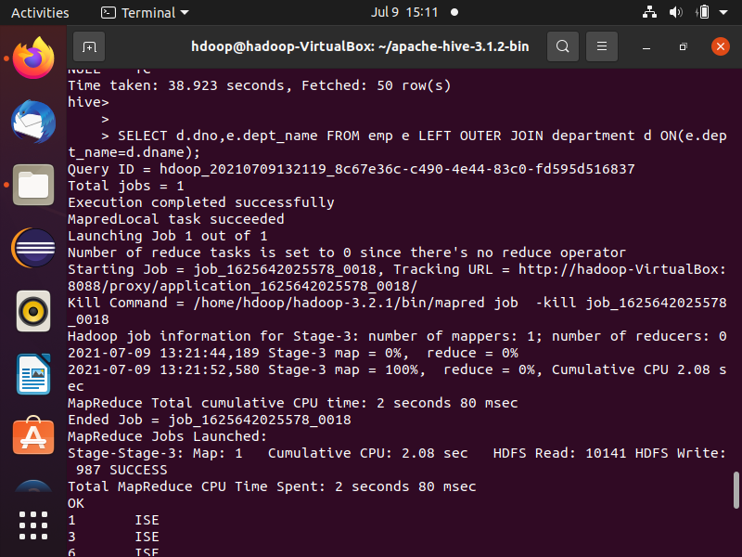

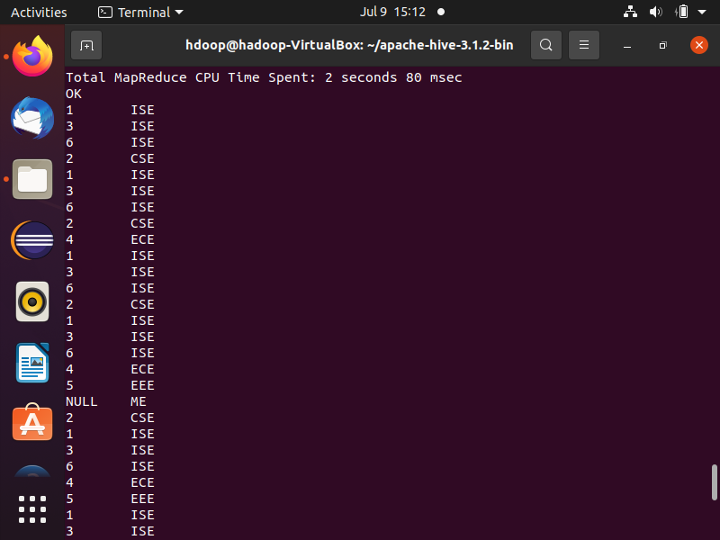

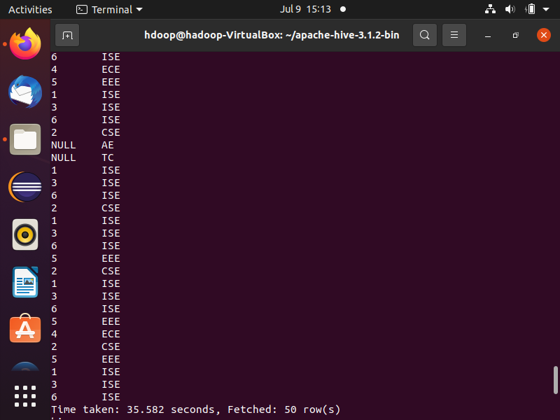

Right outer join:-

